Enhancing Cloud Data Security Using Paillier Homomorphic Encryption Algorithm

Project Phase-I Report submitted to Osmania University, Hyderabad, in partial fulfillment of the requirement for the award of the degree of
Bachelor of Engineering
in
Computer Science

by

Mr. Mohammed Abdul Kareem (160923753004)
Mr. Mohammed Farhaan Ahmed (160923753038)
Mr. Mohammed Imad Uddin (160923753044)

Under the Guidance of
Mrs. B. Nagalakshmi
Assistant Professor


DEPARTMENT OF COMPUTER SCIENCE

LORDS INSTITUTE OF ENGINEERING AND TECHNOLOGY

(UGC Autonomous)

(Affiliated to Osmania University)
Himayatsagar, Hyderabad,500091

A.Y. 2026-2027

CERTIFICATE
This is to certify that the Project Phase-I report entitled Enhancing Cloud Data Security Using Paillier Homomorphic Encryption Algorithm being submitted by Mr. Mohammed Abdul Kareem (160923753004), Mr. Mohammed Farhaan Ahmed (160923753038), Mr. Mohammed Imad Uddin (160923753044) in partial fulfillment of the requirements for the award of the degree of Bachelor of Engineering in Computer Science is a record of Bonafide work carried out by them.

Internal Project Guide
Mrs. B. Nagalakshmi Dr. K. Nagi Reddy
Assistant Professor H.O.D, I.T

External Examiner

DECLARATION BY THE CANDIDATES

We, Mr. Mohammed Abdul Kareem (160923753004), Mr. Mohammed Farhaan Ahmed (160923753038), Mr. Mohammed Imad Uddin (160923753044), hereby declare that the Project Phase-I report entitled Enhancing Cloud Data Security Using Paillier Homomorphic Encryption Algorithm is carried out under the guidance of Mrs. B. Nagalakshmi, Assistant Professor, Department of Information Technology, Lords Institute of Engineering and Technology, Hyderabad is submitted in partial fulfillment of the requirements for the award of the degree of Bachelor of Engineering in Computer Science.

This is a record of Bonafide work carried out by us and the results embodied in this project have not been reproduced or copied from any source. The results embodied in this project report have not been submitted to any other university or institute for the award of any other degree or diploma.

Mr. Mohammed Abdul Kareem (160923753004)
Mr. Mohammed Farhaan Ahmed (160923753038)
Mr. Mohammed Imad Uddin (160923753044)

ACKNOWLEDGMENT

We are very pleased to present this thesis of our project. This period of our student life has been truly rewarding a number of people were of immense help to us during the course of our research and the preparation of our thesis.

First, we wish to thank GOD Almighty who created heavens and earth, who helped us in completing this project and we also thank our parents who encouraged us in this period of research.

We would like to express our sincere gratitude to The Management of Lords Institute of Engineering and Technology, Hyderabad for providing us with an excellent platform and resources to successfully carry out this project.

We would also like to thank Dr. Ravi Kishore Singh, Principal, L.I.E.T. for extending his help in overall completion of this project work.

We would like to express our deep sense of gratitude to Dr. K. Nagi Reddy, Professor & HOD, Information Technology, Lords Institute of Engineering & Technology, Hyderabad, for his encouragement and cooperation throughout the project.

We would like to thank Mrs. B. Nagalakshmi, Assistant Professor, Dept. of Information Technology, Lords Institute of Engineering & Technology, Hyderabad, our project internal guide, for her guidance and help. Her insight during the course of our research and regular guidance were invaluable to us.

Lastly, we acknowledge the support of our faculty members, friends, and family, who inspired and encouraged us throughout this journey.

Mr. Mohammed Abdul Kareem (160923753004)
Mr. Mohammed Farhaan Ahmed (160923753038)
Mr. Mohammed Imad Uddin (160923753044)

Vision of the Institute
Lords Institute of Engineering and Technology strives for excellence in professional education through quality, innovation and teamwork and aims to emerge as a premier institute in the state and across the nation.
Mission of the Institute
- To impart quality professional education that meets the needs of present and emerging technological world.
- To strive for student achievement and success, preparing them for life, career and leadership.
- To provide a scholarly and vibrant learning environment that enables faculty, staff and students to achieve personal and professional growth.
- To contribute to advancement of knowledge, in both fundamental and applied areas of engineering and technology.
- To forge mutually beneficial relationships with government organizations, industries, society and the alumni.


Vision of the Department:
To be a frontier in Information Technology focusing on quality professional education, innovation and employability.
Mission of the Department:
DM1: Adopt innovative teaching learning processes to achieve stated outcomes and sustained performance levels.
DM2: Provide learner centric environment to enrich knowledge, skills and innovation through industry academia collaborations.
DM3: Train the concerned stakeholders on latest technologies to meet the industry needs.
DM4: Inculcate leadership, professional, interpersonal skills and ethical values to address contemporary societal issues.
Note: DM: Department Mission



B.E Computer Science Program Educational Objectives (PEOs):

PEO1 | Be a competent software engineer in IT and allied industry providing viable solutions.
PEO2 | Exhibit professionalism, engage in lifelong learning and adapt to changing industry and societal needs.
PEO3 | Be effective as an individual and also cohesive in a group to execute multidisciplinary projects.
PEO4 | Pursue higher studies in Information Technology with emphasis on competency and innovation.

B.E Computer Science Program Outcomes (POs):
S. No. | Program Outcomes (POs)
1. | PO1: Engineering Knowledge: Apply knowledge of mathematics, natural science, computing, engineering fundamentals and an engineering specialization as specified in WK1 to WK4 respectively to develop the solution of complex engineering problems.
2. | PO2: Problem Analysis: Identify, formulate, review research literature and analyze complex engineering problems reaching substantiated conclusions with consideration for sustainable development. (WK1 to WK4)
3. | PO3: Design/Development of Solutions: Design creative solutions for complex engineering problems and design/develop systems/components/processes to meet identified needs with consideration for the public health and safety, whole-life cost, net zero carbon, culture, society and environment as required. (WK5)
4. | PO4: Conduct Investigations of Complex Problems: Conduct investigations of complex engineering problems using research-based knowledge including design of experiments, modelling, analysis & interpretation of data to provide valid conclusions. (WK8).
5. | PO5: Engineering Tool Usage: Create, select and apply appropriate techniques, resources and modern engineering & IT tools, including prediction and modelling recognizing their limitations to solve complex engineering problems. (WK2 and WK6)
6. | PO6: The Engineer and The World: Analyze and evaluate societal and environmental aspects while solving complex engineering problems for its impact on sustainability with reference to economy, health, safety, legal framework, culture and environment. (WK1, WK5, and WK7).
7. | PO7: Ethics: Apply ethical principles and commit to professional ethics, human values, diversity and inclusion; adhere to national & international laws. (WK9)
8. | PO8: Individual and Collaborative Team work: Function effectively as an individual, and as a member or leader in diverse/multi-disciplinary teams.
9. | PO9: Communication: Communicate effectively and inclusively within the engineering community and society at large, such as being able to comprehend and write effective reports and design documentation, make effective presentations considering cultural, language, and learning differences
10. | PO10: Project Management and Finance: Apply knowledge and understanding of engineering management principles and economic decision-making and apply these to one’s own work, as a member and leader in a team, and to manage projects and in multidisciplinary environments.
11. | PO11: Life-Long Learning: Recognize the need for, and have the preparation and ability for i) independent and life-long learning ii) adaptability to new and emerging technologies and iii) critical thinking in the broadest context of technological change. (WK8)
Engineering Graduates will be able to:


B.E Computer Science Program Specific Outcomes (PSOs):

PSO1 | Professional Skills: Identify, analyze requirements, design and implement computer programs in the area of artificial intelligence, machine learning, big data analytics and networking of varying complexity.
PSO2 | Problem-Solving Skills: Deliver quality service to IT industry and provide solutions to real-life problems applying modern computer languages, software methods and tools.

Course Outcomes: Project Phase- I
After completion of the project, the student will be able to

S. No | Description | Blooms Taxonomy Level
PP.I.CO1 | Demonstrate the ability to synthesize and apply the knowledge and skills acquired in the academic program to the real-world problems. | BTL3
PP.I.CO2 | Evaluate different solutions based on economic and technical feasibility | BTL4
PP.I.CO3 | Effectively plan a project and confidently perform all aspects of project management. | BTL5
PP.I.CO4 | Demonstrate effective written and oral communication skills | BTL4
PP.I.CO5 | Prepare the documentation report and perform the presentation of the project work | BTL3

Course Articulation Matrix:
Mapping of Course Outcomes (COs) with Program Outcomes (POs) and Program Specific Outcomes (PSOs):
Course Outcomes (COs) | Program Outcomes (POs) |  |  |  |  |  |  |  |  |  |  | Program Specific Outcomes  (PSOs)
 | PO1 | PO2 | PO3 | PO4 | PO5 | PO6 | PO7 | PO8 | PO9 | PO  10 | PO  11 | PSO1 | PSO2
PP.I.CO1 | 3 | 2 | 2 | - | 2 | 2 | - | - | 3 | - | - | 2 | 2
PP.I.CO2 | 3 | 3 | 2 | 3 | 2 | - | 2 | - | 3 | - | - | - | 2
PP.I.CO3 | 3 | 3 | 3 | - | 3 | 3 | 1 | 2 | 2 | 3 | 2 | 3 | -
PP.I.CO4 | 3 | 2 | 2 | 3 | 3 | 3 | 3 | 2 | - | - | 2 | 3 | 3
PP.I.CO5 | 3 | 3 | 3 | 3 | 3 | 3 | 3 | 2 | 3 | 3 | - | 3 | 3
AVG | 3 | 2.6 | 2.5 | 3 | 2.6 | 2.7 | 2.2 | 2 | 2.9 | 3 | 2 | 2.7 | 2.5

Level:
1-Low correlation (Low), 2- Medium correlation (Medium), 3-High correlation (High)
SDG Mapping:

SDG | Mapped Indicator | SDG | Mapped Indicator | SDG | Mapped Indicator
 |  |  |  | 
 |  |  |  | 
 |  |  |  | 
 |  |  |  | 
 |  |  |  | 
 |  | 

ABSTRACT

Cloud computing has become an essential technology for storing and managing large volumes of data due to its scalability, flexibility, and cost-effectiveness. However, storing sensitive information on third-party cloud servers introduces significant security and privacy challenges, including unauthorized access, data leakage, and vulnerabilities in cryptographic key management. Conventional encryption techniques protect data confidentiality during transmission and storage, but cloud platforms generally require decryption before computations can be performed, exposing plaintext data to potential server-side compromise. To overcome these limitations, this project proposes a secure cloud data storage and privacy-preserving framework utilizing the Paillier Homomorphic Encryption Algorithm (PHEA) combined with symmetric cryptographic standards.

The proposed system adopts a hybrid encryption architecture implemented as a Django web application. File data is secured using the Advanced Encryption Standard (AES) in Cipher Block Chaining (CBC) mode with dynamically generated keys, while Paillier Homomorphic Encryption is employed for secure cryptographic key verification and privacy-preserving homomorphic operations. The framework integrates strict administrative control mechanisms, including user account state verification (Pending, Verified, Rejected, Blocked) and role-based decryption request approvals. Users verify their assigned Paillier key share before obtaining session permissions to perform encryption. Experimental evaluations demonstrate that the proposed PHEA achieves an efficient encryption time of 19 ms and a decryption time of 35 ms for 5,000 bytes compared to conventional hybrid verification approaches. The framework effectively ensures end-to-end data confidentiality, prevents unauthorized server-side decryption, and provides robust access control for cloud-stored data.

Keywords: Cloud Data Security, Paillier Homomorphic Encryption Algorithm, AES-128-CBC, Hybrid Encryption, Key Verification, Access Control, Decryption Request Approval.

CONTENTS

Certificate i
Declaration ii
Acknowledgement iii
Vision and Mission of the Institute iv
Vision and Mission of the Department v
Program Educational Objectives vi
Program Outcomes vii
Program Specific Outcomes viii
Course Outcomes ix
Course Articulation Matrix x
Abstract xi
Contents xii
List of Figures xiv
List of Tables xv

Chapter 1: Introduction 1-5
1.1 Introduction
1.2 Background
1.3 Problem Statement
1.4 Objectives of the Project
1.5 Scope of the Project

Chapter 2: Literature Survey 6-10
2.1 Introduction
2.2 Review of Related Works

Chapter 3: System Analysis 11-14
3.1 Existing System
3.2 Proposed System
3.3 System Requirements Specifications
3.4 Feasibility Study

Chapter 4: System Design 15-22
4.1 System Architecture
4.2 Data Flow Diagram (DFD)
4.3 UML Diagrams
4.4 Homomorphic and Cryptographic Engine Design

Chapter 5: Implementation 23-30
5.1 Introduction
5.2 System Modules
5.3 Cryptographic Methodology & Mathematical Workflow
5.4 Technologies Used

Chapter 6: Coding and Testing 31-41
6.1 Execution Workflow
6.2 Software Testing Methodologies
6.3 Test Cases
6.4 Result Analysis & Performance Evaluation
6.5 Expected Input and Output Screenshots

Chapter 7: Conclusion and Future Enhancements 42-45
7.1 Conclusion
7.2 Future Enhancements

References 46-48

List of Figures
SI.no | Fig.no | Name of the Figure | Page No
1. | 4.1 | System Architecture of the Secure File Encryption and Decryption System | 15
2. | 4.2 | Data Flow Diagram (DFD) for the Secure File Encryption and Decryption System | 16
3. | 4.3.1 | Use Case Diagram for the Secure File Encryption and Decryption System | 18
4. | 4.3.2 | Class Diagram of the System Entities | 19
5. | 4.3.3 | Sequence Diagram for File Upload and Encryption | 20
6. | 4.3.4 | Activity Diagram for User Registration | 21
7. | 6.5.1 | Main Home Screen | 38
8. | 6.5.2 | User Registration Screen | 39
9. | 6.5.3 | Administrator Login Screen | 39
10. | 6.5.4 | Paillier Key Management Screen | 40
11. | 6.5.5 | Administrator Decryption Request Approval Queue | 40
12. | 6.5.6 | Paillier Key Verification and File Encryption Interface | 41
13. | 6.5.7 | View Encrypted Data and Hex Preview Interface | 41

List of Tables
SI.no | Table.no | Name of the Table | Page No
1. | 6.3 | Comprehensive Test Cases and Validation Matrix (TC-01 to TC-40) | 33-37

CHAPTER 1
INTRODUCTION

1.1 Introduction

Cloud computing has become an integral foundation of modern computing infrastructure, offering elastic storage, on-demand computation, and flexible resource accessibility across the internet. Organizations and enterprise users increasingly depend on third-party cloud environments to maintain vast amounts of operational and transactional data without the overhead of physical infrastructure management. However, delegating data management to commercial cloud providers introduces critical vulnerabilities concerning data confidentiality, unauthorized inspection, and uncontrolled access.

Traditional security practices rely on encrypting data prior to transmission or while stored in cloud databases. Although standard symmetric encryption safeguards data at rest against external eavesdroppers, it poses a fundamental limitation: data must be decrypted back into plaintext before any meaningful computation, aggregation, or analytical operation can take place on the server. This processing requirement exposes raw plaintext data to potential memory scraping, insider threats, and platform-level vulnerabilities within the cloud host.

Homomorphic encryption directly mitigates this vulnerability by allowing specific mathematical operations to be executed on ciphertexts without decrypting them. The Paillier Homomorphic Encryption Algorithm (PHEA) is an asymmetric, probabilistic cryptosystem that features additive homomorphic capabilities. Under Paillier encryption, a cloud server can additively aggregate encrypted numerical values directly, yielding an encrypted sum that decrypts to the sum of the original plaintext inputs.

This project implements a hybrid cloud data security architecture developed within a Python/Django framework. File contents are secured using the Advanced Encryption Standard in Cipher Block Chaining mode (AES-128-CBC), while Paillier cryptography is integrated for cryptographic key verification, secure key-share distribution, and privacy-preserving numerical operations. The system combines homomorphic and symmetric encryption with strict administrative authorization and role-based access control, ensuring robust protection of cloud-hosted information across its entire operational lifecycle.

1.2 Background of the Project

The rapid and widespread transition from traditional on-premises data centers to distributed cloud computing environments has fundamentally transformed how organizations and individual users store, process, and manage digital assets. Cloud computing provides elastic storage scalability, high availability, and on-demand computational resources without the heavy capital expenditure and operational maintenance overhead associated with physical hardware infrastructure. However, entrusting sensitive information—such as financial records, corporate documents, and personal user data—to third-party commercial cloud providers introduces critical vulnerabilities concerning data confidentiality, unauthorized inspection, and uncontrolled access.

To safeguard digital assets against external eavesdroppers and unauthorized access during network transit or database storage, conventional security frameworks rely heavily on cryptographic techniques. Standard symmetric encryption algorithms, such as the Advanced Encryption Standard (AES), offer rapid and computationally efficient encryption and decryption mechanisms suitable for handling bulk files and unstructured binary streams. Despite their efficiency, symmetric cryptosystems suffer from a fundamental architectural limitation: encrypted data cannot undergo any meaningful server-side computation, aggregation, or analytical processing without first being decrypted back into plaintext. Consequently, whenever a cloud server needs to process or verify stored information, raw plaintext data is temporarily exposed in memory, creating significant security windows vulnerable to memory scraping, platform-level compromises, and insider threats.

To address this limitation without sacrificing cloud computational utility, advanced cryptographic research has focused on homomorphic encryption. Unlike traditional ciphers, homomorphic cryptosystems allow specific mathematical operations to be executed directly on ciphertexts without prior decryption.

Among these, the Paillier Homomorphic Encryption Algorithm (PHEA) developed by Pascal Paillier stands out as an asymmetric, probabilistic public-key cryptosystem possessing additive homomorphic properties. Under Paillier encryption, a cloud server can additively combine encrypted numerical values directly, producing an encrypted aggregate sum that decrypts exclusively to the correct sum of the original plaintext inputs, while keeping individual values completely opaque to the processing host.

Building upon these cryptographic principles, this project establishes a robust hybrid cloud data security framework implemented within a Python and Django web application architecture. By pairing the high-throughput performance of symmetric AES-128-CBC bulk file encryption with the cryptographic verification and additive homomorphic capabilities of the Paillier cryptosystem, the proposed system achieves a secure balance between data confidentiality, efficient storage management, and controlled server-side utility.

1.3 Problem Statement

Storing sensitive data on third-party cloud servers introduces significant security risks, as the data is managed by an external provider. While standard encryption protects data at rest, conventional systems require data to be decrypted before any computation can take place, exposing plaintext to potential server-side compromise. Furthermore, traditional storage systems suffer from insecure key management, lack admin-governed decryption controls, and leave files vulnerable if database access is breached. Therefore, the problem is to protect cloud-stored files and perform computations on sensitive numerical data without exposing plaintext values or granting unauthorized access to the cloud server.

1.4 Objectives of the Project

The primary objective is to enhance cloud data security using a hybrid approach combining the Paillier Homomorphic Encryption Algorithm and the Advanced Encryption Standard (AES).

The specific objectives are:
- Encrypt cloud-stored files efficiently using AES-128-CBC.

- Apply Paillier Homomorphic Encryption to enable addition directly on encrypted numerical values without prior decryption.
- Implement Paillier-based key verification to validate users before granting encryption privileges.

- Incorporate role-based access control and an administrator approval workflow for user accounts and decryption requests.
- Prevent direct plaintext exposure by storing only encrypted payloads and providing hex previews.

- Evaluate system performance based on encryption time, decryption time, and computational overhead.

1.5 Scope of the Project

This project focuses on the design and implementation of a secure cloud data storage web application developed using Python and Django.
The scope includes:

- Hybrid Cryptography: Utilizing AES-128-CBC for bulk file encryption and Paillier Homomorphic Encryption for secure key verification and encrypted numerical addition.

- User & Session Management: Managing user lifecycles (Pending, Verified, Rejected, Blocked), password hashing, and session-based encryption permissions (allow_encrypt).

- Encrypted File Operations: Storing concatenated IV and ciphertext in the database, offering hex-encoded previews, and supporting encrypted file downloads.

- Governed Decryption Workflow: Requiring administrative approval for decryption requests before file owners can retrieve the original plaintext.

- Performance Evaluation: Benchmarking cryptographic operations, specifically measuring encryption and decryption runtimes.

CHAPTER 2
LITERATURE SURVEY

2.1 Introduction

Cloud computing provides scalable storage and distributed computational services across modern enterprises. However, delegating data management to third-party cloud environments introduces risks regarding unauthorized access, side-channel leakage, compromised key infrastructure, and data privacy violations. While traditional cryptographic standards secure data at rest, they require decryption prior to execution, creating critical security exposures during data processing. Consequently, researchers have explored homomorphic cryptosystems, post-quantum key encapsulation, blockchain-based management, and artificial intelligence to mitigate these threats. This chapter reviews relevant existing literature and establishes the technical basis for the proposed hybrid security framework.

2.2 Review of Related Works

2.2.1 Security-Performance Optimization in Cloud-Based Bank Data Processing Using HE-ZKP-ORAM (2026)

Authors: Tuan Nguyen Kim and Nguyen Minh Nhut Pham

Contribution: Proposed a secure cloud banking data-processing architecture integrating Homomorphic Encryption (HE), Zero-Knowledge Proofs (ZKP), and Oblivious RAM (ORAM) to safeguard financial transactions during server-side execution.

Drawback: The model is tailored exclusively to banking workflows and incurs significant computational overhead due to recursive ZKP and ORAM protocols. Our project focuses on generalized cloud file security, using a lighter hybrid combination of AES-128-CBC and Paillier encryption.

2.2.2 Cloud Data Privacy Protection with Homomorphic Algorithm: A Systematic Literature Review (2025)

Authors: Michael Ayitey Junior, Peter Appiahene, Obed Appiah, and Kwabena Adu

Contribution: Conducted a comprehensive survey of homomorphic encryption algorithms in cloud privacy, evaluating execution time, communication overhead, and computational resource demands across schemes.

Drawback: The paper provides an analytical literature survey rather than an implemented system. Our work delivers a practical, deployable Django-based architecture featuring integrated file handling, access control, and key management.

2.2.3 HHEML: Hybrid Homomorphic Encryption for Privacy-Preserving Machine Learning on Edge (2025)

Authors: Yu Hin Chan, Hao Yang, Shiyu Shen, Xingyu Fan, Shengzhe Lyu, Patrick S. Y. Hung, and Ray C. C. Cheung

Contribution: Introduced a hybrid homomorphic framework coupling symmetric cryptography with fully homomorphic encryption (FHE) on edge computing hardware for privacy-preserving machine learning inference.

Drawback: The architecture requires specialized hardware acceleration and focuses on machine learning edge inference rather than structured cloud data storage.

2.2.4 Pura: An Efficient Privacy-Preserving Solution for Face Recognition (2025)

Authors: Guotao Xu, Bowen Zhao, Yang Xiao, Yantao Zhong, Liang Zhai, and Qingqi Pei

Contribution: Developed a privacy-preserving biometric verification framework utilizing a threshold Paillier cryptosystem to compute Euclidean distances on encrypted facial vectors.

Drawback: Pura is customized specifically for biometric vector matching. In contrast, our system provides general-purpose file encryption, user lifecycle management, and privacy-preserving numerical operations.

2.2.5 Encrypted Vector Similarity Computations Using Partially Homomorphic Encryption (2025)

Authors: Sefik Serengil and Alper Ozpinar

Contribution: Analyzed partially homomorphic cryptosystems (including Paillier and ElGamal) to evaluate vector similarity computations across encrypted databases in recommendation systems.

Drawback: Focuses strictly on similarity scoring algorithms without addressing broader cloud storage requirements such as role-based access control, file integrity.

2.2.6 Post-Quantum Key Encapsulation Mechanism in Cloud Storage

Authors: Altarawni et al.

Contribution: Designed a post-quantum cloud security scheme using the Kyber Key Encapsulation Mechanism (KEM) to safeguard key exchange against quantum cryptanalytic attacks.

Drawback: Focuses primarily on key exchange and encapsulation without providing direct support for arithmetic operations or homomorphic evaluations over encrypted data.
2.2.7 Blockchain-Based Dynamic Key Management for Cloud Data Security

Authors: Shakor et al.

Contribution: Proposed combining dynamic AES encryption with a distributed blockchain ledger to manage cryptographic keys securely and prevent centralized key compromise.

Drawback: The blockchain ledger introduces notable latency, computational overhead, and network complexity. Our proposed framework achieves secure key verification and governance via Paillier key-shares without requiring a decentralized ledger.

2.2.8 Genetic Algorithm-Based Distributed Cloud Storage Security

Authors: Kamal et al.

Contribution: Developed a privacy-aware heuristic optimization framework using genetic algorithms to balance data security and storage distribution across multi-cloud nodes.

Drawback: The iterative nature of genetic algorithms results in high computational complexity, making it less practical for real-time file encryption and retrieval pipelines.

2.2.9 Deep Learning and Multi-Layer Encryption in IoT Cloud Systems

Authors: Raju et al.

Contribution: Proposed a multi-tier security framework combining deep learning models, hybrid encryption, and blockchain to secure healthcare records in IoT-cloud integrations.

Drawback: The model introduces substantial resource demands and architectural complexity. Our project implements a focused multi-tier architecture using AES-128-CBC and Paillier verification to maximize practical efficiency.

2.2.10 Enhanced Encryption Standards for Distributed Cloud Environments

Authors: Reyana et al.

Contribution: Investigated pre-storage encryption standards, demonstrating the critical need to encrypt data client-side or during transit before cloud persistence occurs.

Drawback: Analyzes standard symmetric encryption pipelines without incorporating homomorphic computation capabilities or an administrative decryption-request approval process

CHAPTER 3
SYSTEM ANALYSIS

3.1 Existing System
In conventional cloud storage environments, client applications typically upload files and data payloads directly to remote, centralized cloud servers. Data protection in these legacy architectures relies predominantly on network-level transport encryption, standard user authentication (e.g., username/password), and the perimeter access policies enforced by the cloud hosting provider. Once files reach the server backend, they are frequently stored as plaintext or protected via transparent server-side encryption using keys managed directly by the provider.

3.1.1 Disadvantages of the Existing System
- Plaintext Exposure During Processing: Stored data must be completely decrypted back into plaintext in cloud memory whenever any computational manipulation, verification, or aggregation is required.
- Exposure to Compromised Infrastructure: If an unauthorized adversary breaches the storage server or underlying database, all sensitive user files are exposed in readable format.
- Vulnerability to Credential Theft: Standard authentication fails to isolate the underlying data; an attacker obtaining user credentials gains unrestricted access to all stored assets.
- Centralized Key Management Risks: Encryption keys are commonly held and controlled by the service provider, introducing severe risks of key misuse or unauthorized exposure.
- Lack of Multi-Tier Decryption Governance: Traditional models lack independent administrative workflows or multi-party approval pipelines before sensitive data can be decrypted.
- Insufficient Access Monitoring: Unmonitored decryption permissions prevent administrators from auditing or restricting suspicious file retrieval operations in real time.

3.2 Proposed System
The proposed system implements a secure cloud data storage and privacy-preserving computation platform built using a Python and Django web framework. It adopts a hybrid cryptographic architecture that pairs the computational efficiency of AES-128-CBC for bulk file encryption with the mathematical capabilities of the Paillier Homomorphic Encryption Algorithm (PHEA) for key verification, key-share distribution, and encrypted arithmetic aggregation.
To eliminate unauthorized decryption and data exposure, the system introduces a mandatory user validation lifecycle and an administrator-mediated decryption approval pipeline. Files are encrypted on the client side prior to persistence, stored exclusively as initialization vector (IV) and ciphertext bytes, and exposed to standard interfaces only as hexadecimal previews.

3.2.1 Advantages of the Proposed System
- Strong Storage Confidentiality: File payloads are converted to ciphertext before database insertion, preventing data leakage even if the database is directly compromised.
- Efficient Bulk Encryption: Utilizes symmetric AES-128-CBC with dynamically generated keys to provide high-speed file encryption without computational bottlenecks.
- Homomorphic Key & Numerical Operations: Integrates Paillier cryptography to verify client key shares and compute additions directly on encrypted numerical attributes without plaintext exposure
- Governed User Lifecycle: Restricts system access to accounts verified by the system administrator (Pending, Verified, Rejected, Blocked).
- Pre-Encryption Permission Gating: Enforces mandatory Paillier key-share validation before granting temporary session privileges (allow_encrypt) to upload and encrypt files.
- Admin-Approved Decryption Workflow: Prevents direct client-side decryption; users must submit formal requests that require administrator approval before decryption keys are provisioned.
- Secure Credential Handling: Protects user authentication credentials using Django's cryptographically secure password hashing algorithms.

3.3 Requirement Specifications
3.3.1 Hardware Requirements
- Processor: Intel Core i3 / i5 processor (or equivalent dual-core CPU, 2.0 GHz or higher)
- RAM: 4 GB minimum (8 GB recommended for cryptographic benchmarking)
- Hard Disk: 20 GB of available storage space for application files, virtual environments, and encrypted storage
- Input Devices: Standard keyboard and mouse
- Display: Standard monitor with 1024x768 resolution or higher

3.3.2 Software Requirements
- Operating System: Windows 10/11, Ubuntu Linux (18.04 LTS or higher), or macOS
- Programming Language: Python 3.8+
- Web Framework: Django Framework (v3.2+ / v4.0+)
- Cryptographic Libraries: cryptography (for AES-128-CBC primitives), phe / custom Paillier implementation (for PHEA operations)
- Database: SQLite (default development database) / MySQL (production database backend)
- Web Browser: Modern web browser supporting HTML5/CSS3 (Google Chrome, Mozilla Firefox, or Microsoft Edge)
- Development Tools: VS Code, PyCharm, or any standard Python IDE

3.4 Feasibility Study
A feasibility study was carried out to assess the operational, technical, and economic viability of deploying the proposed hybrid encryption system:

- Technical Feasibility: The system leverages established, production-ready technologies: the Python runtime, the Django web framework, and standard cryptographic primitives. Combining AES-128-CBC for bulk binary processing with Paillier homomorphic encryption for lightweight key checks and scalar additions ensures that computational overhead remains well within normal system capacities (demonstrating ~19 ms encryption and ~35 ms decryption benchmarks). Therefore, the project is technically feasible.

- Operational Feasibility: The user and administrator workflows are designed with intuitive, responsive web interfaces. Role-based separation allows standard users to easily navigate file upload, preview, and request workflows, while administrators can review accounts and approve decryption tasks seamlessly through centralized dashboards. The solution integrates smoothly into existing IT operational environments.

- Economic Feasibility: The entire software ecosystem is built using open-source platforms (Python, Django, SQLite/MySQL). It requires no specialized hardware accelerators, commercial software licenses, or proprietary third-party subscriptions, making the system cost-effective to develop, deploy, and maintain

CHAPTER 4
SYSTEM DESIGN

4.1 System Architecture
The system employs a multi-tier web application architecture designed to maintain strict separation between client interaction, core business logic, cryptographic processing, and persistent database storage.
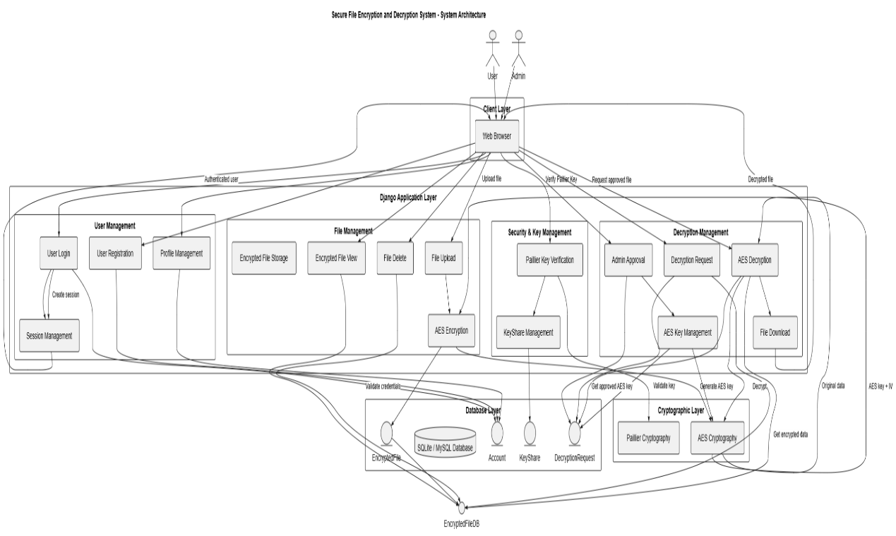
Figure 4.1: System Architecture of the Secure File Encryption and Decryption System

- Client Layer: Standard web browsers used by data owners, data users, and system administrators to interact with the platform.
- Django Application Layer: The core application engine managing routing, authentication, business workflows, session controls, and administrative approvals.
- Cryptographic Layer: The underlying cryptographic utilities containing:
  - AES Cryptography: Encrypts and decrypts bulk raw file bytes using symmetric AES-128 in Cipher Block Chaining (CBC) mode with unique Initialization Vectors (IV).
  - Paillier Cryptography: Performs probabilistic asymmetric key operations, supporting key-share validation and additive homomorphic evaluation.
- Database Layer: Persists structured system models including user account states, Paillier key shares, encrypted file payloads, and decryption request queues.

4.2 Data Flow Diagram (DFD)
A Data Flow Diagram maps the flow of information through the system, the transformation processes applied to that data, and the persistent data stores involved.
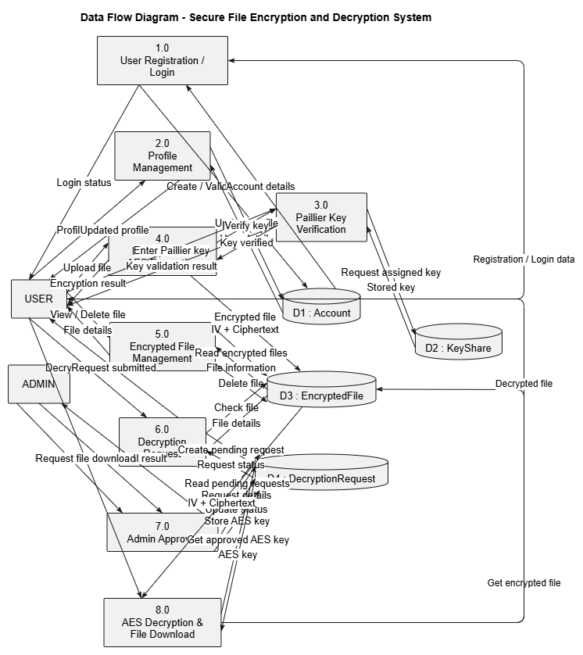
Figure 4.2: Data Flow Diagram (DFD) for the Secure File Encryption and Decryption System
- Process 1.0 (User Registration / Login): User submits credentials; system validates fields, hashes passwords, sets account state to Pending, and authenticates verified users.
- Process 2.0 (Profile Management): Verified users review and update contact and profile details.
- Process 3.0 & 4.0 (Paillier Key Verification): The user enters their assigned key. The system verifies it against the KeyShare model using Paillier algorithms and sets allow_encrypt = True upon success.
- Process 5.0 (Encrypted File Management): Raw uploaded files are encrypted with an ephemeral AES-128 key. The IV and ciphertext are concatenated and stored in D3: EncryptedFile.
- Process 6.0 & 7.0 (Decryption Request & Admin Approval): The user logs a decryption request into D4: DecryptionRequest. The administrator reviews and approves the request, binding the corresponding AES decryption key.
- Process 8.0 (AES Decryption & Download): Validates ownership and approval, separates IV and ciphertext, executes AES-128-CBC decryption, and streams the decrypted file to the user.

4.3 UML Diagrams
The Unified Modeling Language (UML) standardizes the visual representation of system architecture, interactions, and state behaviors.

4.3.1 Use Case Diagram
The Use Case Diagram defines the behavioral interactions between the system actors (User and Admin) and the available system functions.
- User Actor:
  - Register Account, Login, Logout
  - View Profile, Update Profile
  - Verify Paillier Key
  - Upload File, Encrypt File
  - View Encrypted Files (Hex preview), Download Encrypted File
  - Request Decryption, View Decryption Status
  - Decrypt File, Download Decrypted File
  - Delete Encrypted File

- Admin Actor:
  - Login, Logout
  - Review User Accounts (Approve User, Reject User, Block User)
  - Review Decryption Requests (Approve Decryption Request, Associate AES Key)
  - KeyShare Management

- Underlying Validation & Utility Cases (Include / System Operations):
  - Validate Email, Validate Mobile, Validate Password, Hash Password
  - Generate AES Key, Perform AES Encryption / Decryption

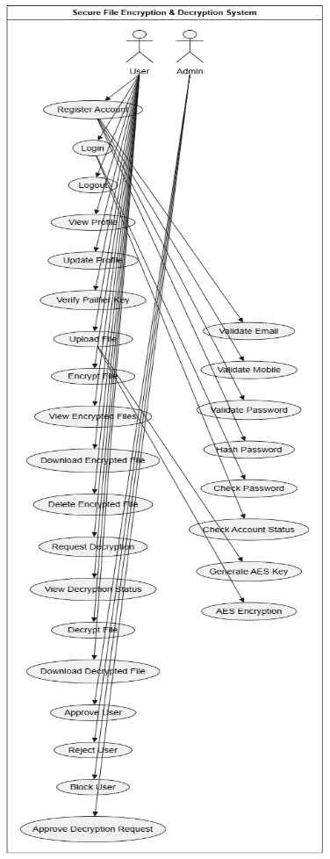
Figure 4.3.1: Use Case Diagram for the Secure File Encryption and Decryption System
4.3.2 Class Diagram
The Class Diagram models the static structural design of the system, depicting database entities, object attributes, and model relationships.
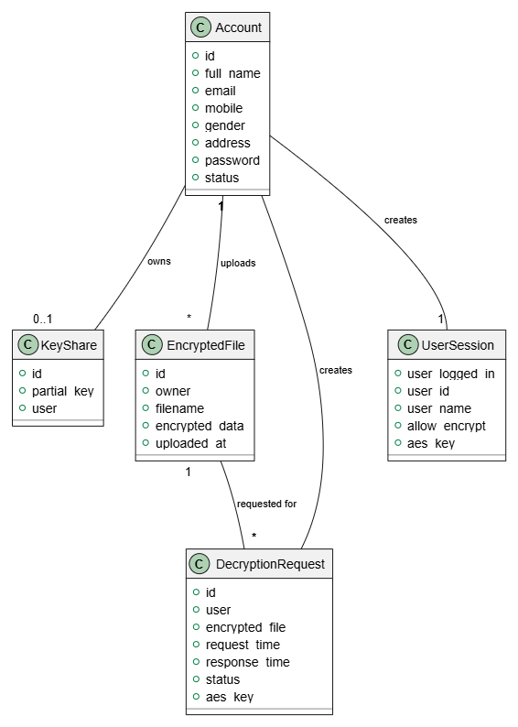
Figure 4.3.2: Class Diagram of the System Entities
4.3.3 Sequence Diagram
The Sequence Diagram documents the chronological sequence of interactions that occur during the file upload and encryption workflow.
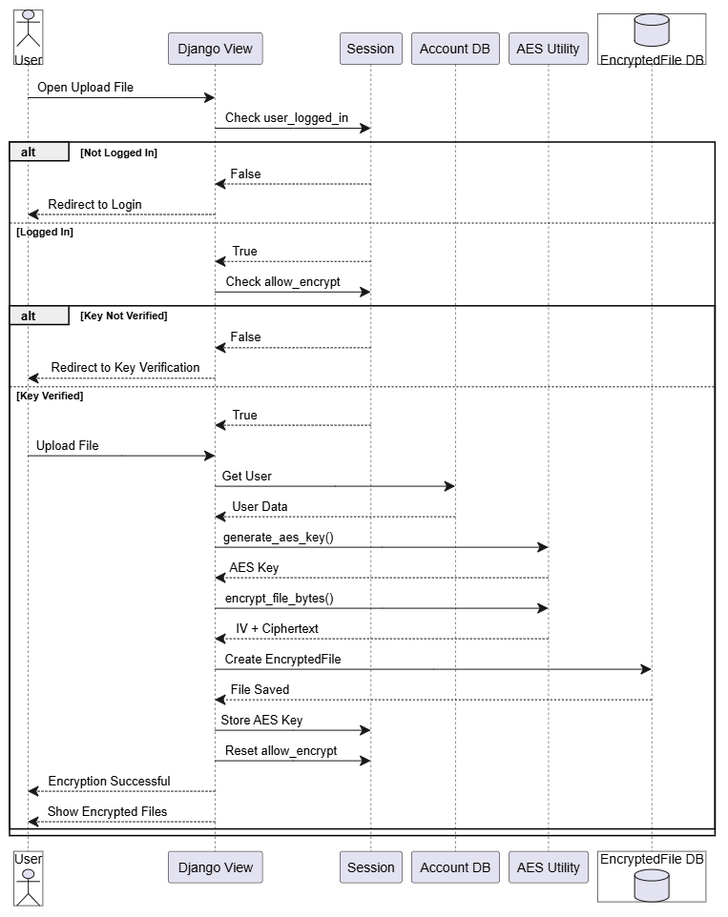
Figure 4.3.3: Sequence Diagram for File Upload and Encryption

4.3.4 Activity Diagram

The Activity Diagram models the logical operational workflow for new user registration and initial input validation.

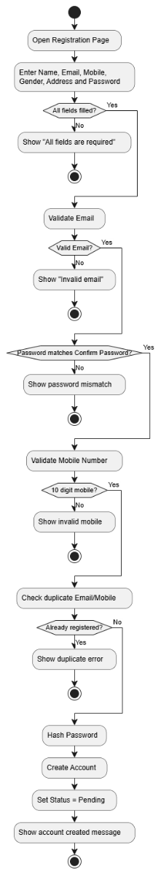
Figure 4.3.4: Activity Diagram for User Registration

4.4 Homomorphic and Cryptographic Engine Design

The system's cryptographic layer combines symmetric bulk encryption with asymmetric homomorphic evaluation:
- AES-128-CBC Bulk File Processing:
  - Raw input files are parsed as contiguous byte sequences.
  - A cryptographically secure 128-bit key and a 128-bit Initialization Vector ($IV$) are generated.
  - Plaintext bytes are padded to match AES block boundaries (16 bytes) according to PKCS#7 conventions.
  - The resulting ciphertext is combined with the $IV$ (payload = IV + ciphertext) and stored in the database.

- Paillier Homomorphic Key & Computation Framework:
  - Key Generation: Two large prime numbers $p$ and $q$ of equal bit length are selected such that $\gcd\left(pq,\left(p-1\right)\left(q-1\right))=1\right)$. The modulus is computed as $n=pq$, and $λ=\text{lcm}\left(p-1,q-1\right)$.
  - Encryption: For a message $m∈Z_{n}$, a random integer $r∈Z_{n}^{*}$ is selected. The ciphertext is:

$$c=g^{m}⋅r^{n} \left(mod n^{2}\right)$$

  - Additive Homomorphism: Given two ciphertexts $c_{1}=E\left(m_{1}\right)$ and $c_{2}=E\left(m_{2}\right)$, the product of the ciphertexts corresponds to the sum of the plaintexts:

$$c_{\text{sum}}=c_{1}⋅c_{2} \left(mod n^{2}\right)=\left(g^{m_{1}}r_{1}^{n}\right)\left(g^{m_{2}}r_{2}^{n}\right) \left(mod n^{2}\right)=g^{m_{1}+m_{2}}{\left(r_{1}r_{2}\right)}^{n} \left(mod n^{2}\right)=E\left(m_{1}+m_{2}\right)$$

  - This property enables intermediate aggregations (such as transaction balances or data usage metrics) to be computed in the cloud without decrypting individual entries

CHAPTER 5
IMPLEMENTATION

5.1 Introduction
The implementation phase translates system design specifications, mathematical models, and architectural workflows into a secure, functional web application. The primary goal of the "Enhancing Cloud Data Security" system is to secure user data prior to cloud database persistence through a hybrid cryptographic mechanism combining symmetric encryption (AES-128-CBC) and asymmetric homomorphic encryption (Paillier Cryptosystem). Developed using Python and the Django framework, the platform enforces strict access boundaries between client and administrative actors, mandatory cryptographic key verification, and controlled decryption approval pipelines. This chapter details the technical methodologies, architectural module breakdowns, cryptographic workflows, and development technologies utilized across the system.

5.2 System Modules
The system architecture is structured into eleven interconnected functional modules, separating administrative supervision, user lifecycle workflows, and cryptographic primitives.

Module 1: User Registration & Authentication Module
- Account Registration: Gathers essential client parameters including full name, email address, mobile number, gender, physical address, and password.
- Input Validation: Enforces structural validations such as email format verification, 10-digit mobile number constraints, and duplicate account checking against stored records.
- Password Hashing: Secures client credentials using Django’s PBKDF2 algorithm via make_password() to prevent plaintext credential exposure.
- Access Control Gating: Automatically places new accounts in a Pending state. Login attempts are cross-checked via check_password(), permitting system entry only when an account holds an administratively verified state (Verified) while rejecting Pending, Rejected, or Blocked statuses.

- Session Management: Initializes isolated, secure HTTP session states upon authenticated login and purges them completely upon user logout.

Module 2: Admin Authentication Module
- Administrative Login: Authenticates designated administrative personnel using dedicated administrative credentials.
- Session Isolation: Creates isolated administrative session contexts, granting access to global system management dashboards while preventing unauthorized cross-role session escalation.
- Session Flush: Implements complete administrative session flushing on logout.

Module 3: User Management Module (Admin)
- Account Auditing: Provides an administrative overview of all registered client profiles, tracking personal details, timestamps, and active account states.
- Lifecycle State Transitions:
  - Verify: Upgrades Pending user accounts to Verified, allowing standard login privileges.
  - Reject: Denies activation to pending accounts violating registration criteria.
  - Block: Temporarily suspends active verified accounts suspected of policy violations.
  - Unblock: Reinstates suspended accounts to active status.
  - Delete: Permanently purges user accounts and associated relational records from the database.

Module 4: Key Generation & Management Module
- Paillier Key Pair Generation: Generates an asymmetric, probabilistic Paillier homomorphic key pair (public key and private key) for each administratively verified user.
- AES Key Generation: Provisions a 128-bit symmetric key alongside the homomorphic structure.
- Key Serialization & Persistence: Serializes complex cryptographic key objects into portable strings using pickle and base64 encoding. These are persisted within the KeyShare model linked via a one-to-one relationship with the user's account.
- Administrative Key Overview: Enables administrators to review key assignments across all registered client accounts.

Module 5: Key Verification Module (User)
- Pre-Encryption Validation: Serves as a security gate before file encryption operations can occur.
- Challenge-Response Matching: Prompts the user to enter their assigned Paillier private key string, trimming whitespace and comparing it against the stored value in KeyShare.
- Session Permission Flagging: Sets an ephemeral session flag (allow_encrypt = True) upon successful match, unlocking file upload permissions for the current session while rejecting invalid key submissions.

Module 6: File Encryption Module
- File Stream Ingestion: Ingests raw binary file streams submitted via validated multi-part forms (request.FILES['file']).
- Permission Verification: Confirms that allow_encrypt is actively asserted in the user's session before processing.
- Symmetric Encryption (AES-128-CBC): Generates an ephemeral 128-bit AES key and a randomized 16-byte Initialization Vector (IV) via PyCryptodome. Plaintext bytes are padded to 16-byte block boundaries via PKCS#7.
- Payload Storage: Concatenates the 16-byte IV with the resulting ciphertext bytes (IV + ciphertext) and persists the combined payload as a BinaryField in the EncryptedFile model.
- Permission Revocation: Immediately resets allow_encrypt to False post-encryption to prevent replay exploits.

Module 7: Encrypted Data Management Module
- Data Listing & Hex Previews: Renders tabular listings of uploaded files containing identifiers, filenames, and upload timestamps, displaying a 60-byte hexadecimal preview of the stored ciphertext rather than plaintext.
- Encrypted File Download: Enables users to download raw encrypted hex dumps as structured .txt files.
- Owner-Restricted Deletion: Allows users to permanently remove their encrypted assets, enforcing strict foreign-key verification to prevent unauthorized deletion of files owned by other users.

Module 8: Decryption Request Module
- Petition Submission: Enables clients to submit formal decryption requests for their stored encrypted assets.
- Duplicate Prevention: Checks the DecryptionRequest model to ensure no duplicate Pending request exists for the same file.
- Audit Logging: Logs request timestamps and establishes an initial tracking state of Pending.
- Request Tracking: Provides clients with an interface to monitor real-time approval status (Pending, Approved, or Rejected).

Module 9: Decryption Approval Module (Admin)
- Administrative Queue: Displays an aggregated list of pending decryption requests submitted across all client accounts.
- Key Association & Authorization: Upon administrator approval, generates and associates the required AES decryption key with the request record, logs the response timestamp, and transitions the state to Approved.

Module 10: File Decryption & Download Module
- Authorization Verification: Confirms that the requesting user owns the target asset and that an active Approved status exists in the corresponding DecryptionRequest record.
- Payload Extraction: Extracts the 16-byte IV from the stored binary payload and isolates the remaining ciphertext bytes.
- Decryption Processing: Retrieves the approved AES key, initializes AES-128-CBC unpadding routines, and restores the original plaintext bytes.
- Comparative Output Delivery: Constructs and streams a downloadable text file containing both the encrypted hexadecimal representation and the restored plaintext content.

Module 11: Profile Management Module
- Metadata Maintenance: Allows authenticated users to review and update contact details including full name, mobile number, gender, and address.
- Identity Lock: Enforces non-blank validation and 10-digit mobile constraints while keeping the email field immutable to maintain database indexing and relational security.

5.3 Cryptographic Methodology and Workflow
The system employs a multi-tiered cryptographic methodology combining symmetric bulk encryption with asymmetric additive homomorphic processing.

- Symmetric Bulk Data Encryption (AES-128-CBC)
For arbitrary files and large data streams, symmetric cryptography provides high-throughput processing with minimal computational overhead:
- Key Generation: A random 128-bit key $K∈{\left\{0,1\right\}}^{128}$ is generated dynamically in volatile memory using secure system entropy.
- Initialization Vector: A random 16-byte vector $IV∈{\left\{0,1\right\}}^{128}$ is instantiated for each encryption instance to ensure identical plaintext blocks produce distinct ciphertexts.
- PKCS#7 Padding: Plaintext byte arrays $M$ are divided into 16-byte blocks. If the final block length is $L<16$, it is padded with $16-L$ bytes, each having the value $16-L$.
- Cipher Block Chaining (CBC): Each padded block $P_{i}$ is XORed with the preceding ciphertext block before encryption:

$$C_{0}=IV$$
$$C_{i}={\text{AES}}_{K}\left(P_{i}⊕C_{i-1}\right) \text{for }i≥1$$

- Storage Concatenation: The binary stored in the database is formed as:
$$\text{Payload}=IV∥C_{1}∥C_{2}∥…∥C_{n}$$

where $∥$ denotes byte concatenation, ensuring that decryption routines can extract the dynamic IV directly from the first 16 bytes.

- Paillier Homomorphic Cryptosystem
The Paillier cryptosystem provides public-key encryption with additive homomorphic capabilities, enabling key-share validation and secure numerical aggregation on untrusted hosts without decryption:
- Key Generation:

  - Select two independent large prime numbers $p$ and $q$ such that:

$$\gcd\left(pq,\left(p-1\right)\left(q-1\right))=1\right)$$

  - Compute the RSA modulus $n=pq$ and determine:

$$λ=\text{lcm}\left(p-1,q-1\right)$$

  - Select a random generator integer $g∈Z_{n^{2}}^{*}$ such that the modular multiplicative inverse:

$$μ={\left(L\left(g^{λ} \operatorname{mod}{n^{2}} \right)\right)}^{-1} \operatorname{mod}{n}$$

exists, where the linear quotient function $L\left(u\right)$ is defined as:

$$L\left(u\right)=\frac{u-1}{n}$$

  - The public encryption key is the tuple $\left(n,g\right)$, and the private decryption key is $\left(λ,μ\right)$.

- Encryption Transformation:

For any plaintext integer message $m∈Z_{n}$, select a random blinding scalar $r∈Z_{n}^{*}$. The ciphertext is computed as:

$$c=g^{m}⋅r^{n} \operatorname{mod}{n^{2}}$$

- Decryption Transformation:

Recovering the original message from ciphertext $c∈Z_{n^{2}}^{*}$ using the private key $\left(λ,μ\right)$ is computed as:

$$m=L\left(c^{λ} \operatorname{mod}{n^{2}} \right)⋅μ \operatorname{mod}{n}$$

- Additive Homomorphic Evaluation:

Given two ciphertexts $c_{1}=E\left(m_{1}\right)$ and $c_{2}=E\left(m_{2}\right)$ encrypted under the identical public key $\left(n,g\right)$, their modular product yields:

$$c_{\text{sum}}=c_{1}⋅c_{2} \operatorname{mod}{n^{2}} =\left(g^{m_{1}}r_{1}^{n}\right)\left(g^{m_{2}}r_{2}^{n}\right) \operatorname{mod}{n^{2}} =g^{m_{1}+m_{2}}{\left(r_{1}r_{2}\right)}^{n} \operatorname{mod}{n^{2}} =E\left(m_{1}+m_{2}\right)$$

This property allows cloud platforms to perform mathematical summations across encrypted numerical parameters without access to the underlying private keys or plaintext data.

5.4 Technologies Used
The system implementation leverages an open-source, production-grade technology stack chosen for security, stability, and development efficiency:

- Python (v3.8+): Serves as the core programming runtime. Python provides built-in memory management, native dynamic typing, robust standard libraries, and comprehensive support for cryptographic arithmetic and binary manipulation.

- Django Web Framework (v3.2+ / v4.0+): Provides the foundational Model-View-Template (MVT) architecture. Django supplies built-in protection against common web vulnerabilities (such as CSRF, SQL injection, and clickjacking), a modular ORM, secure session abstractions, and an administrative interface.

- PyCryptodome / Cryptography: Provides standardized, high-performance cryptographic primitives. It handles secure pseudo-random number generation (PRNG), Initialization Vector instantiation, and hardware-accelerated AES-128 block cipher implementations in CBC mode.

- Python-Paillier (phe): Supplies optimized routines for composite degree residuosity class operations, enabling large-prime generation, modular arithmetic inversion, and homomorphic serialization/deserialization workflows.

- SQLite / MySQL Database: Serves as the persistent relational database backend. SQLite is utilized during local development for lightweight, self-contained persistence, while MySQL is supported for multi-user cloud deployment environments.

- Frontend Web Technologies (HTML5, CSS3, Bootstrap, JavaScript): Powers the presentation layer, delivering clean, responsive, and mobile-friendly form interfaces, status-tracking queues, and hexadecimal data viewers.

CHAPTER 6

CODING AND TESTING

6.1 Execution Workflow
The operational execution of the system follows a structured lifecycle spanning administrative configuration, user validation, cryptographic key provisioning, pre-encryption verification, file encryption, and access-controlled decryption:

- User Registration and Validation: A client accesses the registration portal and submits account parameters. The system verifies field completeness, validates RFC-compliant email syntax, enforces a 10-digit mobile number constraint, and verifies that the email and phone number do not already exist in the database. The password is cryptographically hashed using Django's PBKDF2 algorithm via make_password(). The account is stored in the Account table with an initial status of Pending.

- Administrative Approval and Key Provisioning: The administrator authenticates via the admin portal. The administrator reviews pending accounts and updates the user's status to Verified. Once verified, the administrator executes key provisioning: a Paillier public/private key pair $\left(n,g,λ,μ\right)$ and an initial symmetric key are generated, serialized, and stored in the KeyShare model associated with the user.

- Paillier Key-Share Verification: When a verified user logs in, direct file upload remains locked. To upload and encrypt a file, the user navigates to the key verification portal and submits their assigned Paillier private key share. The backend compares the submitted string against the database record. If verified, the session flag allow_encrypt is set to True, unlocking file upload permissions for that session.

- File Encryption and Cloud Persistence: The user submits a raw data file via the upload interface. The backend confirms that allow_encrypt == True. A dynamic 128-bit AES key and a randomized 16-byte Initialization Vector (IV) are generated. The file bytes are padded using PKCS#7 conventions and encrypted using AES in CBC mode. The IV is prepended to the ciphertext (IV + ciphertext) and saved in the database under the EncryptedFile model. The session flag allow_encrypt is immediately reset to False.

- Decryption Request and Key Association: Users cannot directly decrypt stored files. When an asset is needed, the user submits a decryption request, creating a record in DecryptionRequest with status Pending. The administrator inspects pending requests on the admin dashboard and grants approval, generating and associating the corresponding AES decryption key with the request record and updating the status to Approved.

- Decryption and Plaintext Delivery: The user triggers the download operation. The system confirms user ownership and verifies that the request status is Approved. The binary payload is split to extract the first 16 bytes (IV) and the remaining ciphertext. The AES-128-CBC engine decrypts the payload and strips the PKCS#7 padding. The output is delivered to the user as a text file displaying both the encrypted hexadecimal representation and the restored plaintext.

6.2 Software Testing Methodologies
Software testing verifies that system components function according to specifications and satisfy security benchmarks. The testing framework applies multiple formal methodologies to evaluate application stability, access-control boundaries, and cryptographic execution:

- Unit Testing: Tests individual modules, functions, and decision paths in isolation (e.g., input field validation, password hashing, PKCS#7 padding logic, key generation).

- Integration Testing: Evaluates communication between connected software modules, including session flag propagation, view-to-ORM operations, database key lookups, and cryptographic transformations.

- Functional Testing: Demonstrates that application features perform according to business rules and security requirements across valid and invalid inputs.

- System Testing: Validates end-to-end performance of the complete integrated application across varied runtime configurations.

- White-Box Testing: Evaluates internal code execution paths, exception handlers, conditional branches, and session state transitions.

- Black-Box Testing: Evaluates application behavior from an external perspective based strictly on inputs and expected outputs without internal code knowledge.

- User Acceptance Testing (UAT): Verifies that user management, encrypted file upload, hexadecimal inspection, and administrator approval workflows satisfy operational expectations.

6.3 Test Cases
The system was evaluated against 40 comprehensive test cases covering authentication, administrative controls, key verification, file encryption, data management, and decryption approval workflows.

Table 6.3: Comprehensive Test Cases and Validation Matrix (TC-01 to TC-40)
Test Case ID | Module | Test Case | Input / Action | Expected Result | Status
TC-01 | Registration | Valid user registration | Enter all valid registration details | Account is created with Pending status | Pass
TC-02 | Registration | Empty fields | Submit registration with required fields empty | Validation error is displayed | Pass
TC-03 | Registration | Duplicate email | Register with an existing email | Duplicate account error is displayed | Pass
TC-04 | User Login | Pending user login | Login with pending account credentials | Login is denied with pending-status message | Pass
TC-05 | User Login | Verified user login | Login with valid verified credentials | User dashboard is displayed | Pass
TC-06 | User Login | Invalid password | Enter incorrect password | Login is rejected | Pass
TC-07 | User Login | Blocked user login | Login using blocked account | Access is denied | Pass
TC-08 | User Logout | Logout | Click logout | Session is terminated successfully | Pass
TC-09 | Profile | View profile | Open profile page | User information is displayed | Pass
TC-10 | Profile | Update profile | Modify valid profile details | Updated details are saved | Pass
TC-11 | Key Verification | Valid Paillier key | Enter correct assigned key | Key is verified successfully | Pass
TC-12 | Key Verification | Invalid Paillier key | Enter incorrect key | Key verification fails | Pass
TC-13 | File Upload | Upload valid file | Select and upload a file | File is uploaded and encrypted | Pass
TC-14 | File Encryption | Verify encryption | Upload plaintext file and inspect stored data | Encrypted data is stored instead of plaintext | Pass
TC-15 | Encrypted Files | View encrypted files | Open encrypted-data page | User's encrypted files are displayed | Pass
TC-16 | Encrypted Files | Download encrypted data | Click download encrypted data | Hexadecimal encrypted data is downloaded | Pass
TC-17 | File Management | Delete encrypted file | Select and delete a file | Encrypted file is removed | Pass
TC-18 | Decryption | Request decryption | Submit decryption request | Request is created with Pending status | Pass
TC-19 | Decryption | Duplicate request | Submit another request for same pending file | Duplicate request is prevented/handled | Pass
TC-20 | Decryption | View request status | Open decryption requests | Current request status is displayed | Pass
TC-21 | Decryption | Unauthorized decryption | Try to download before admin approval | Decryption access is denied | Pass
TC-22 | Decryption | Approved decryption | Download file after admin approval | Original file is successfully decrypted | Pass
TC-23 | Admin Login | Valid admin login | Enter valid admin credentials | Admin dashboard is displayed | Pass
TC-24 | Admin Login | Invalid admin login | Enter incorrect credentials | Admin login is rejected | Pass
TC-25 | User Management | Verify user | Admin selects Verify | User status changes to Verified | Pass
TC-26 | User Management | Reject user | Admin selects Reject | User status changes to Rejected | Pass
TC-27 | User Management | Block user | Admin selects Block | User status changes to Blocked | Pass
TC-28 | User Management | Unblock user | Admin selects Unblock | User account becomes active again | Pass
TC-29 | Key Management | Generate keys | Admin generates keys for verified user | Paillier/AES keys are generated and assigned | Pass
TC-30 | Key Management | View user keys | Admin opens key-management page | Assigned key information is displayed | Pass
TC-31 | Decryption Approval | Approve request | Admin approves pending request | Request becomes Approved and decryption is allowed | Pass
TC-32 | User Management | Delete user | Admin deletes a user | User account is removed | Pass
TC-33 | Access Control | Unauthorized admin access | Normal user attempts to access admin page | Access is denied | Pass
TC-34 | Access Control | Unauthorized file access | User attempts to access another user's file | Access is denied | Pass
TC-35 | File Management | Invalid file ID | Request nonexistent file ID | Appropriate error/404 response is displayed | Pass
TC-36 | Encryption/Decryption | Data integrity | Encrypt and decrypt the same file | Decrypted file matches the original file | Pass
TC-37 | Security | Stored data protection | Inspect database for uploaded file content | Original plaintext is not directly stored | Pass
TC-38 | Security | Login protection | Access protected page without login | User is redirected/denied access | Pass
TC-39 | Security | Invalid key access | Enter an unauthorized/invalid key | Access to protected operation is denied | Pass
TC-40 | Security | Decryption approval | Attempt decryption without admin approval | File cannot be decrypted/downloaded | Pass

6.4 Result Analysis and Performance Evaluation
The experimental evaluation confirms that the hybrid cryptographic architecture provides strong data confidentiality while maintaining practical computational efficiency:
- Encryption and Decryption Efficiency: Performance benchmarks demonstrate that for a standard payload of 5,000 bytes, the Paillier Homomorphic Encryption Algorithm and hybrid verification framework achieve an encryption runtime of approximately 19 ms and a decryption runtime of 35 ms.
- Storage Protection: Storing files as concatenated IV + Ciphertext binary payloads prevents unauthorized data exposure, even in the event of direct database extraction.
- Workflow Integrity: Restricting file upload privileges behind a single-use session flag (allow_encrypt), combined with mandatory administrative decryption approvals, prevents unauthorized file modifications and key misuse.

6.5 Expected Input and Output Screenshots
1. Main Home Screen

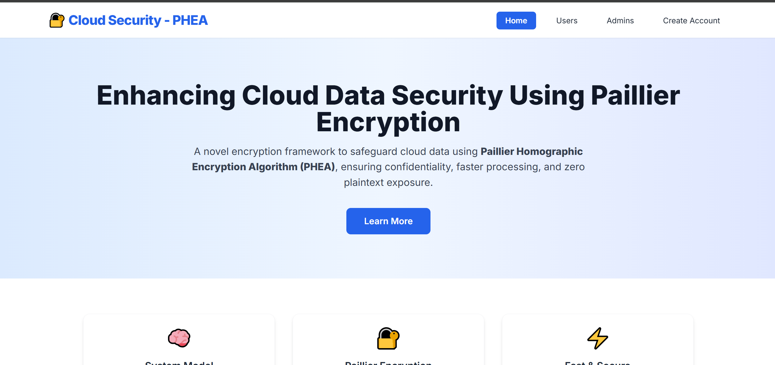
Figure 6.5.1: Main Home Screen

Description: Displays the public landing page with navigation links to User Login, Admin Login, and Registration interfaces.

2. User Registration Screen

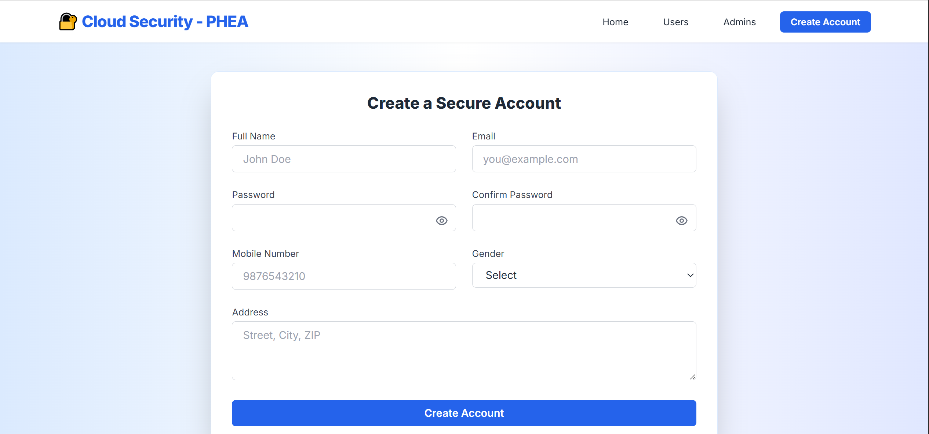
Figure 6.5.2: User Registration Screen

Description: Captures user onboarding fields including Name, Email, 10-digit Mobile Number, Gender, Address, and Password with real-time field validation.

- Admin Login Screen

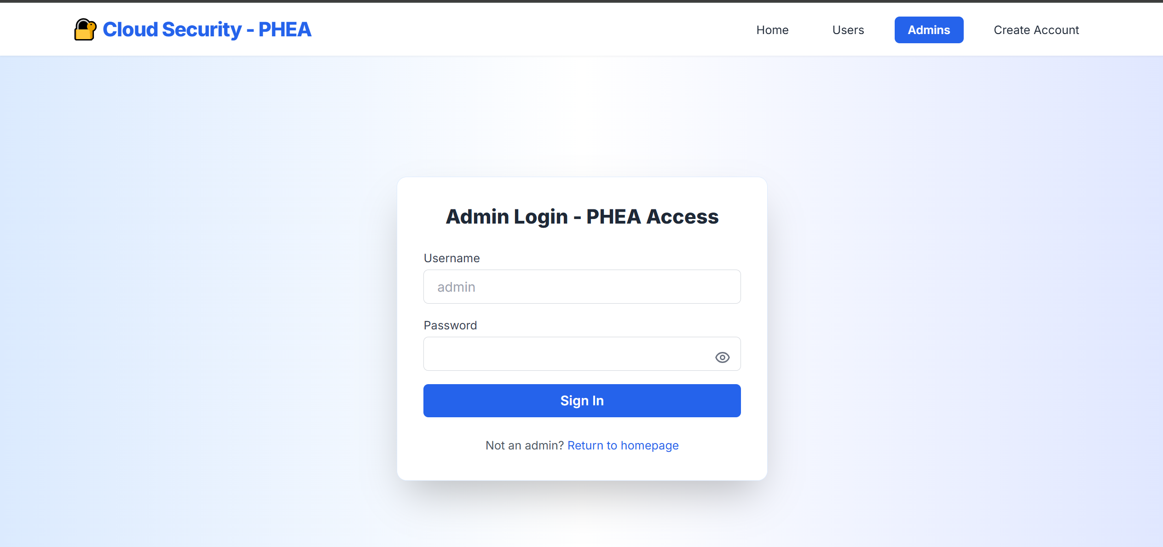
Figure 6.5.3: Administrator Login Screen

Description: Provides secure credential authentication for administrative role access.

- Paillier Key Management Screen

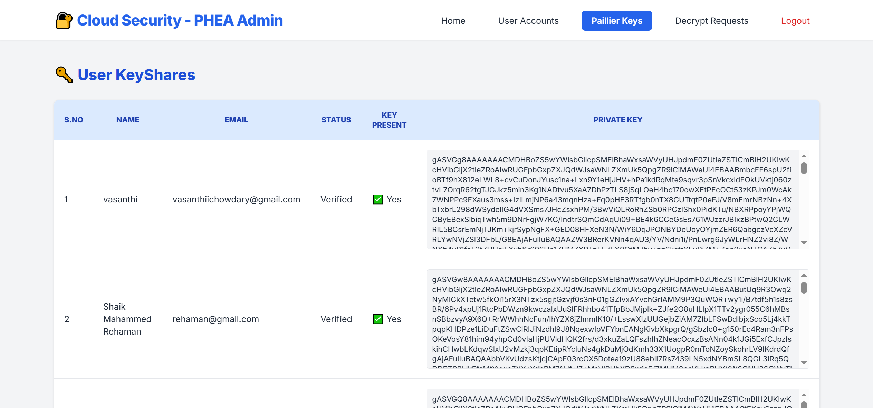
Figure 6.5.4: Paillier Key Management Screen

Description: Administrative view showing generated Paillier public/private key pairs and assigned symmetric key shares for verified users.

- Administrator Decryption Approval Queue

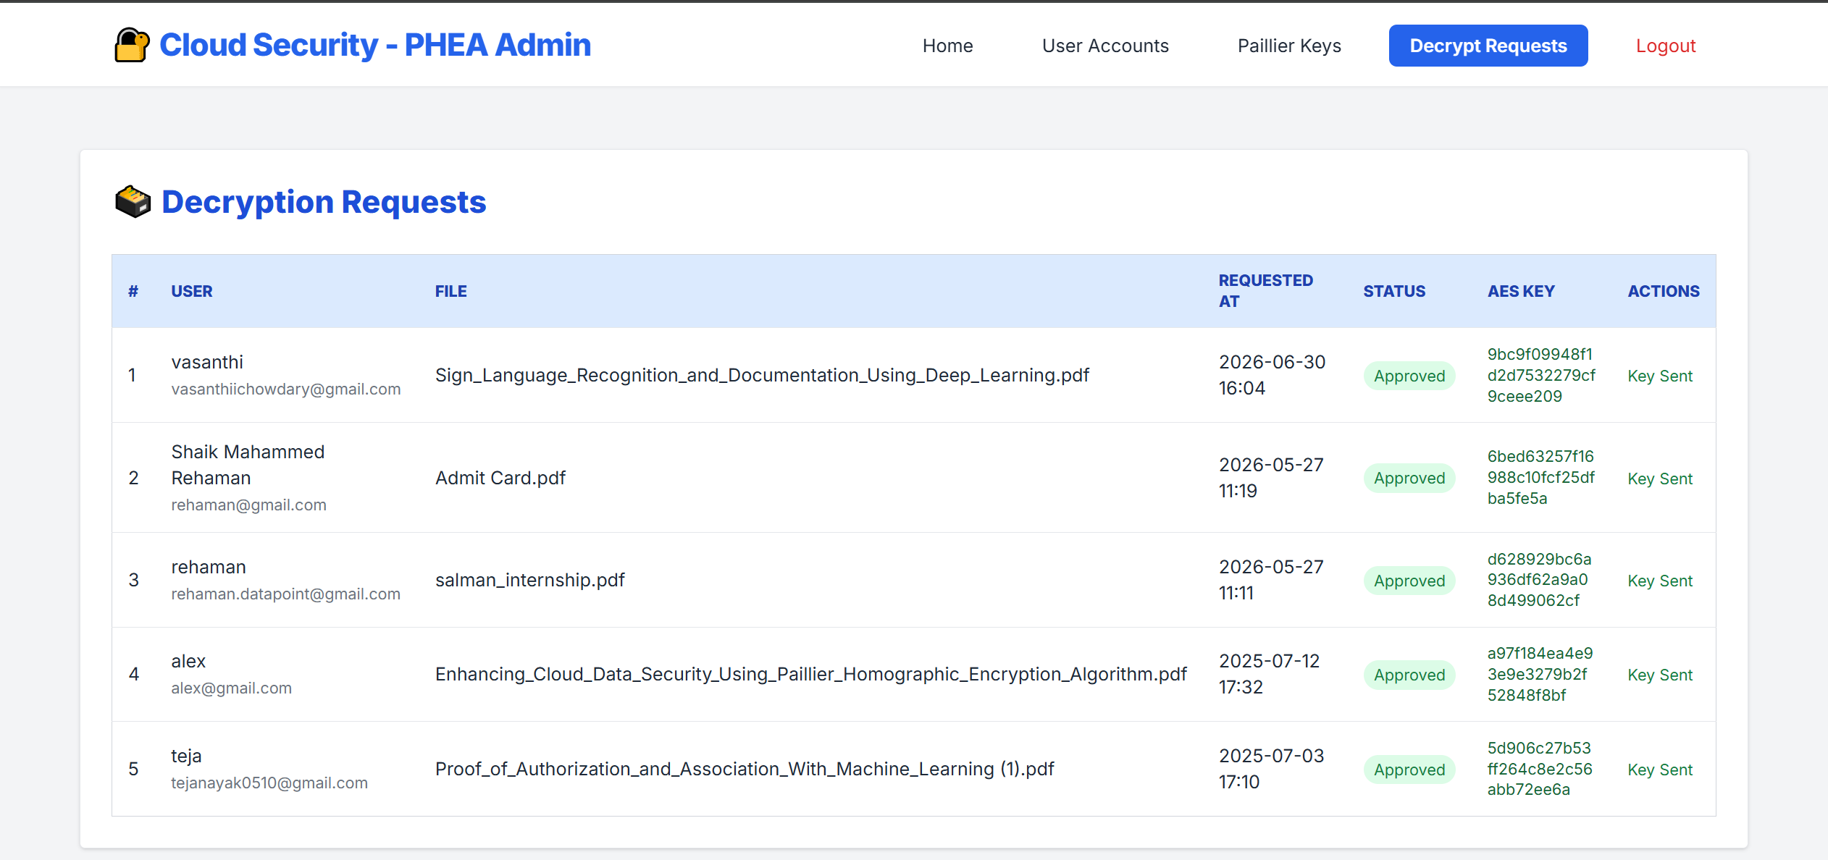
Figure 6.5.5: Administrator Decryption Request Approval Queue

Description: Displays pending user decryption requests requiring administrative review, approval, and AES decryption key assignment.

- Paillier Key Verification and File Encryption Screen

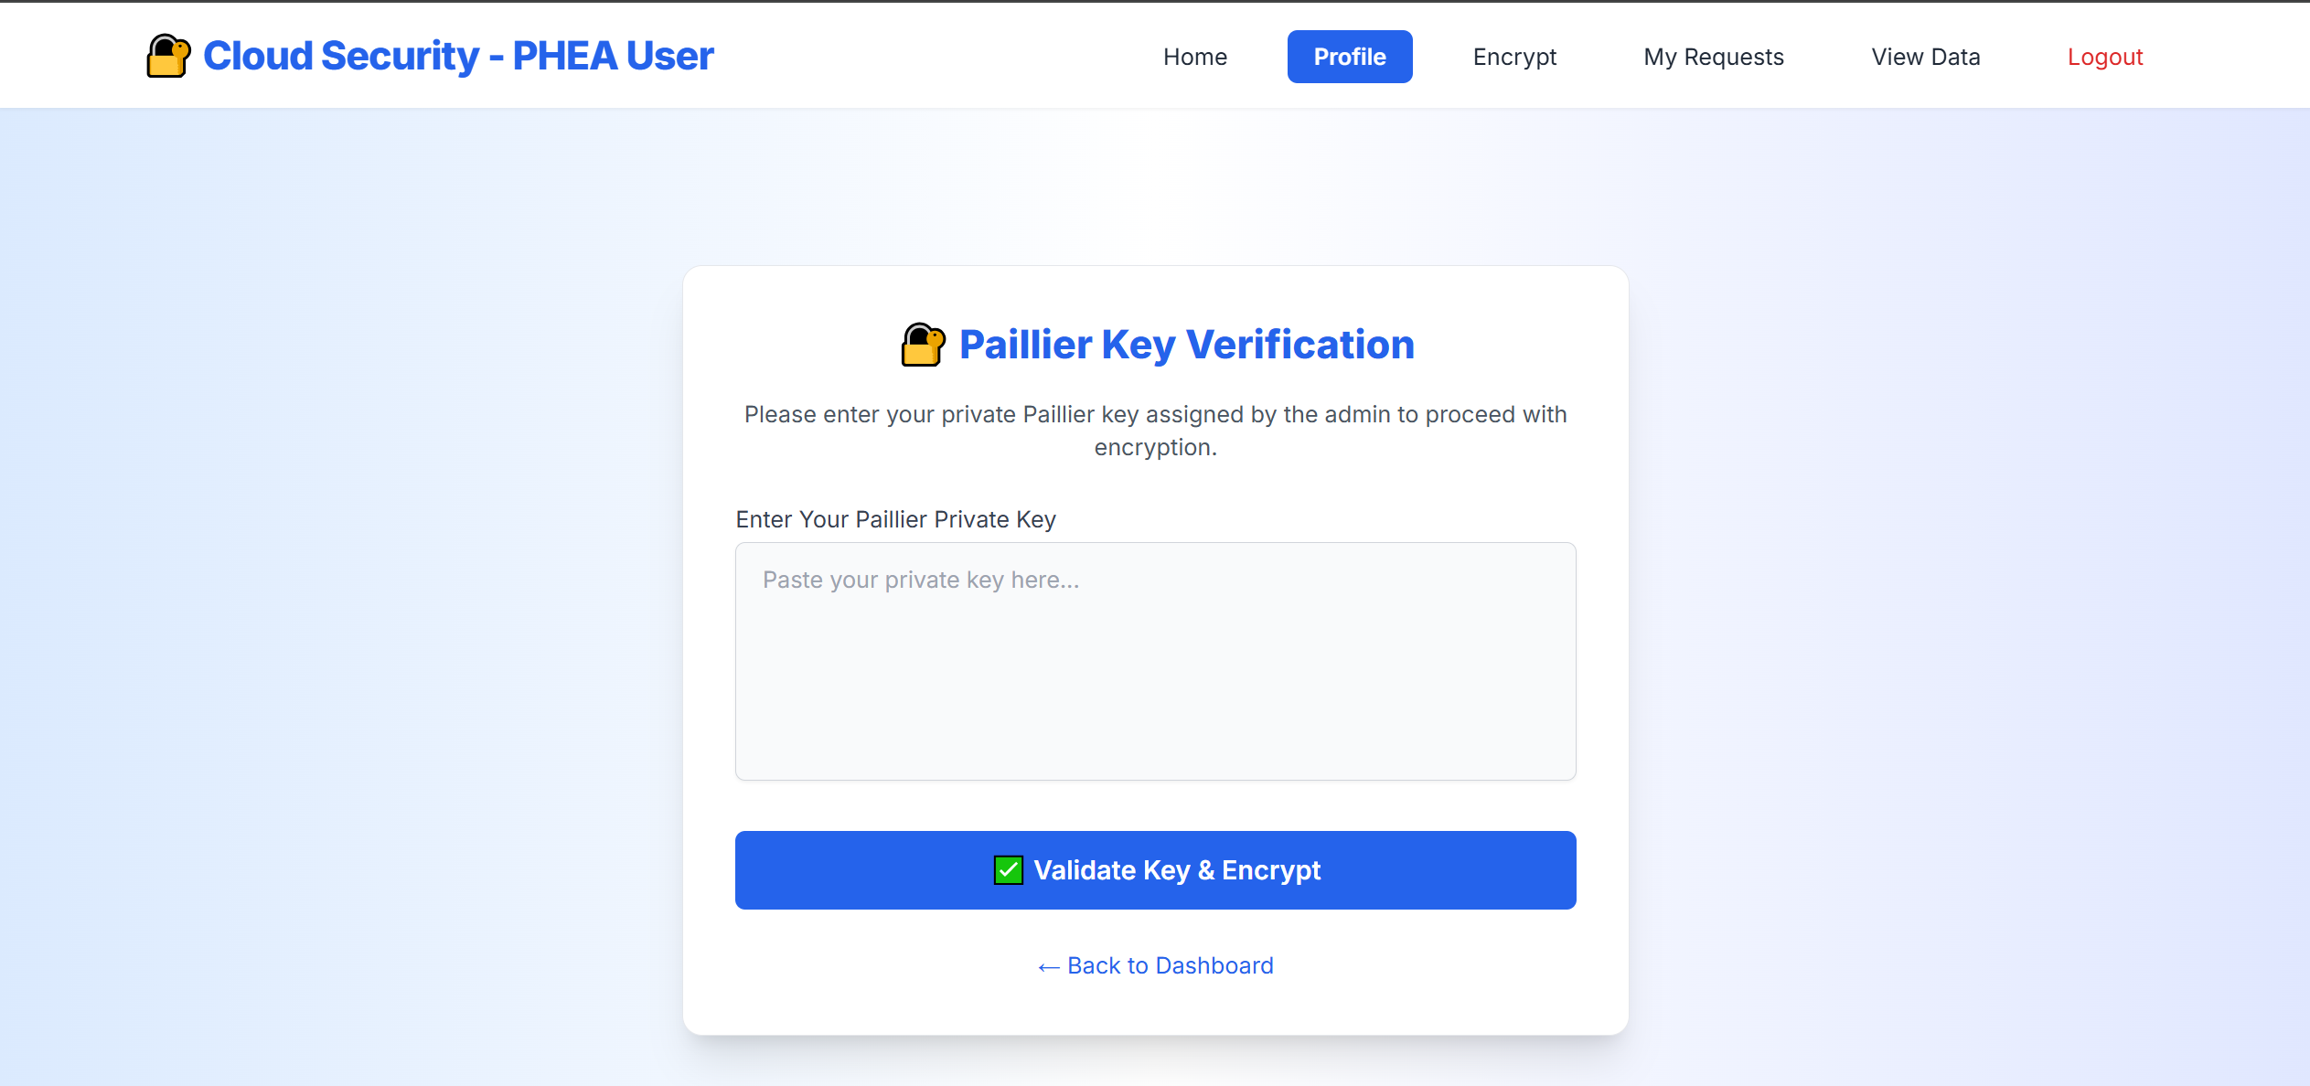
Figure 6.5.6: Paillier Key Verification and File Encryption Interface

Description: Prompts the user to enter their assigned Paillier private key share to set the allow_encrypt permission flag and proceed with file upload and encryption.
- View Encrypted Data and Hex Preview Screen

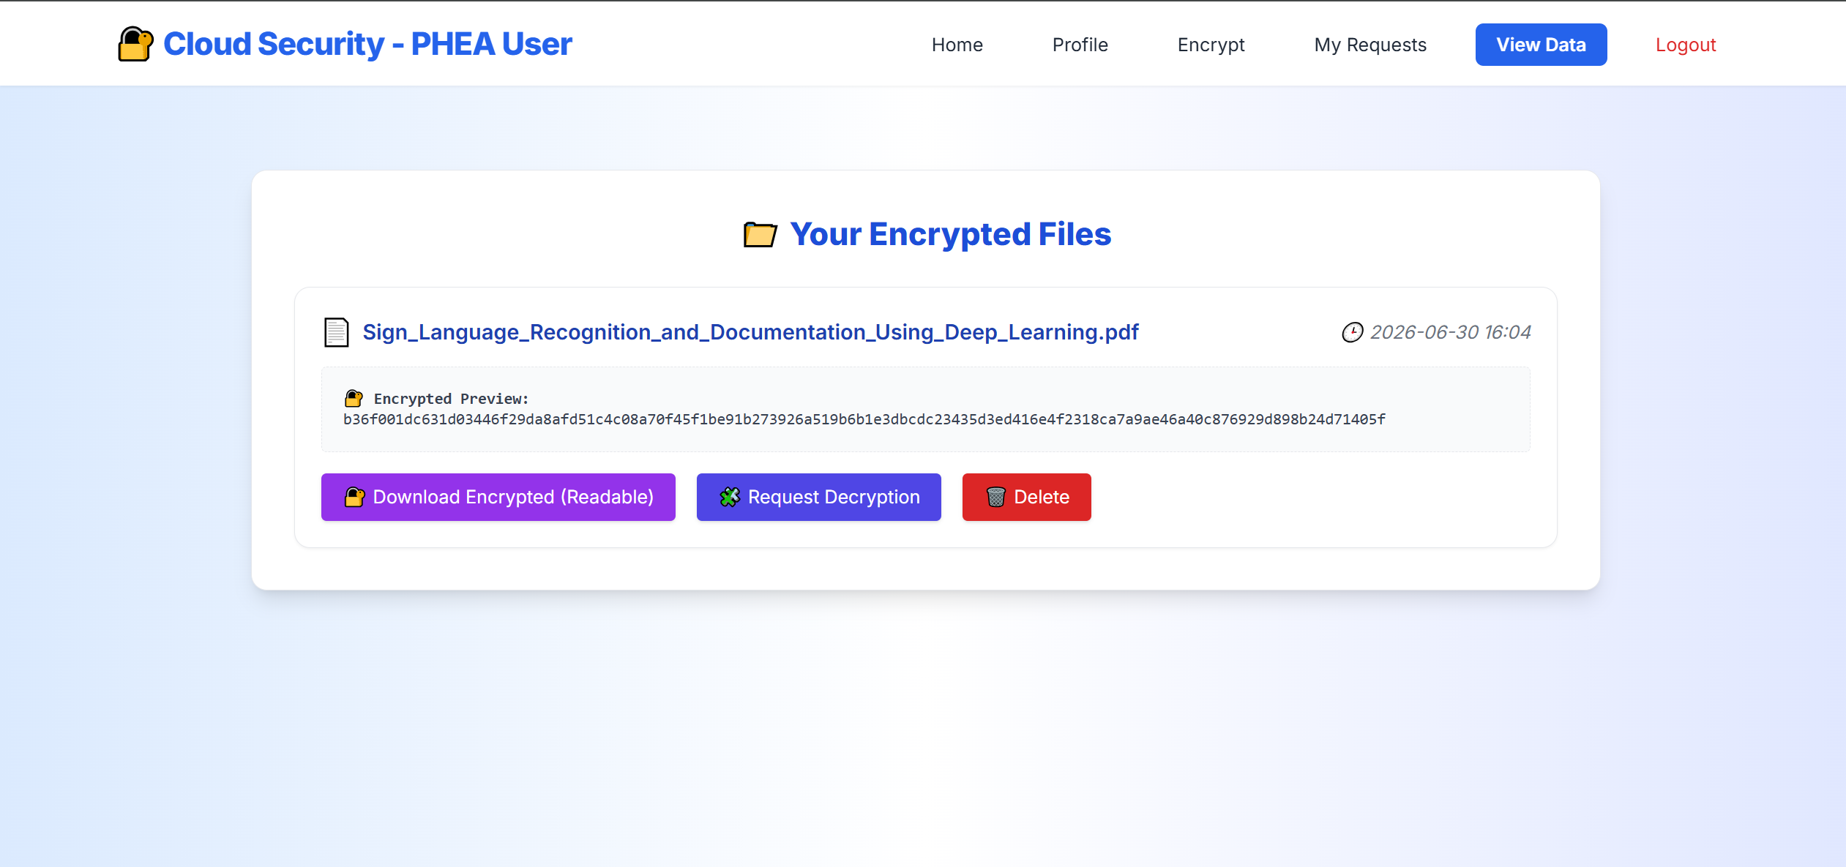
Figure 6.5.7: View Encrypted Data and Hex Preview Interface

Description: Displays stored user files with a 60-byte hexadecimal preview of the ciphertext and options to download the encrypted hex dump or initiate a decryption request.

CHAPTER 7
CONCLUSION AND FUTURE ENHANCEMENT

7.1 Conclusion
The project, "Enhancing Cloud Data Security Using Paillier Homomorphic Encryption Algorithm" addresses critical data confidentiality and privacy challenges inherent in third-party cloud environments. Conventional cloud architectures require stored payloads to be fully decrypted prior to computation, exposing sensitive assets to memory scraping, platform-level vulnerabilities, and insider threats. The system resolves this vulnerability by combining the symmetric efficiency of Advanced Encryption Standard in Cipher Block Chaining mode (AES-128-CBC) with the asymmetric additive properties of the Paillier Homomorphic Encryption Algorithm (PHEA).

The system incorporates a multi-tiered security and access control framework:
- Lifecycle Governance: Client access is restricted via status-based controls (Pending, Verified, Rejected, Blocked), permitting system login and dashboard access only after formal administrative verification.
- Homomorphic Key Distribution & Gating: Administrators provision serialized Paillier public/private key pairs and initial symmetric key shares to verified users. File encryption permissions are strictly gated behind challenge-response Paillier private key verification, activating an ephemeral, single-use session flag (allow_encrypt = True) upon successful match to prevent unauthorized encryption actions.
- Pre-Storage Data Isolation: Uploaded file byte streams are dynamically padded using PKCS#7 conventions and encrypted with dynamic 128-bit AES keys. The 16-byte Initialization Vector (IV) and resulting ciphertext bytes are concatenated (IV + ciphertext) and persisted in the database as binary data. Plaintext is never stored in database records, and files are exposed via user interfaces strictly as 60-byte hexadecimal previews.
- Regulated Decryption Approvals: A petition-and-approval model prevents client-side decryption without administrative approval. When a user submits a decryption request, the administrator reviews the petition, binds the corresponding AES decryption key, and updates the status to Approved. Only then can the file owner execute CBC decryption, strip PKCS#7 padding, and download the restored plaintext alongside comparative encrypted hex dumps.
- Computational Feasibility: Cryptographic benchmarking demonstrates that the Paillier homomorphic verification and encryption mechanism achieves an encryption runtime of 19 ms and a decryption runtime of 35 ms for 5,000-byte payloads, validating its suitability for practical enterprise applications.

The Django-based implementation establishes a secure, practical foundation for privacy-preserving file storage and administrative data governance in cloud platforms.

7.2 Future Enhancements
To build upon the current architecture, several technical enhancements can be integrated to increase security, scalability, and system automation:
- AI-Based Intrusion Detection System (IDS):
  - Integrate machine learning anomaly detection models to monitor user sessions in real time.
  - Identify irregular file-access velocities, atypical download timings, and brute-force credential stuffing, automatically flagging or temporarily transitioning suspicious accounts to Blocked status.

- Advanced Authenticated Hybrid Encryption (AES-256-GCM):
  - Transition symmetric file encryption from AES-128-CBC to AES-256 in Galois/Counter Mode (GCM).
  - Provide simultaneous confidentiality and cryptographic message authentication (integrity verification) via GMAC authentication tags without requiring separate hashing pipelines.

- Secure Key Management and Automated Key Rotation:
  - Integrate dedicated Key Management Services (KMS) or hardware security modules (HSMs) to manage cryptographic lifecycles.
  - Implement automated key rotation schedules and cryptographic envelope versioning to re-key persistent data without rendering archived historical files inaccessible.

- Multi-Factor Authentication (MFA):
  - Introduce Time-Based One-Time Password (TOTP) protocols using standards like RFC 6238.
  - Require secondary verification factors for sensitive administrative actions, including user verification, key generation, and decryption request approval.

- Cloud Object Storage Integration:
  - Decouple file persistence from the relational database by integrating cloud object storage solutions like Amazon S3, Azure Blob Storage, or Google Cloud Storage.
  - Store binary ciphertext payloads directly in private cloud storage buckets while retaining encryption metadata, key shares, and access audit records within the relational database.

- Cryptographic File Integrity Verification:
  - Compute keyed-hash message authentication codes (HMAC-SHA256) or SHA-3 checksums across file byte streams prior to encryption.
  - Validate checksums during decryption to detect accidental transmission corruption or unauthorized storage-level modifications before delivering plaintext to clients.

- Tamper-Evident Audit Logging:
  - Implement append-only cryptographic audit logs for all security-relevant transactions, including account state changes, key checks, file uploads, and decryption approvals.
  - Structure logs into verifiable hash chains to prevent log tampering and support verifiable forensic auditing.

- Permission-Controlled Secure File Sharing:
  - Extend the authorization model to allow verified file owners to grant selective, temporary decryption permissions to other registered users.
  - Enforce time-limited access tokens, maximum download counts, and instant access revocation mechanisms.

- Granular Role-Based Access Control (RBAC):
  - Expand user access beyond binary User and Admin tiers to include structured operational roles like Security Officer, Auditor, Group Manager, and Standard Client.
  - Enforce separation of duties, ensuring administrators managing user accounts cannot unilaterally access or approve sensitive cryptographic decryption keys.

- Automated Event Notifications and Security Alerts:
  - Configure asynchronous SMTP/SMS alert pipelines to notify administrators of account registrations, blocked user attempts, and pending decryption requests.
  - Automatically dispatch status notifications to users when their decryption requests are approved or rejected.

- Encrypted Disaster Recovery and Backup:
  - Deploy automated backup workflows to export encrypted database snapshots and Paillier key shares to physically separated, geo-redundant storage.
  - Ensure recovery pipelines can restore system operations and re-establish cryptographic key bindings following catastrophic infrastructure failures.

- Centralized Security Analytics Dashboard:
  - Provide administrators with graphical analytics tracking total encrypted data volumes, active user state distributions, average approval latency, and cryptographic execution metrics.
  - Assist security officers in monitoring platform activity and identifying potential operational bottlenecks.

REFERENCES

[1] M. E. Misri, “Enhancing Cloud Data Security Using Paillier Homomorphic Encryption Algorithm,” in 2025 3rd International Conference on Integrated Circuits and Communication Systems (ICICACS), 2025, doi: 10.1109/ICICACS65178.2025.10968860.

[2] T. N. Kim and N. M. N. Pham, “Security-Performance Optimization in Cloud-Based Bank Data Processing Using HE-ZKP-ORAM,” Engineering, Technology & Applied Science Research, vol. 16, no. 2, pp. 33760–33765, 2026, doi: 10.48084/etasr.16654.

[3] M. A. Junior, P. Appiahene, O. Appiah, and K. Adu, “Cloud Data Privacy Protection with Homomorphic Algorithm: A Systematic Literature Review,” Journal of Cloud Computing, vol. 14, art. no. 84, 2025, doi: 10.1186/s13677-025-00774-5.

[4] Y. H. Chan, H. Yang, S. Shen, X. Fan, S. Lyu, P. S. Y. Hung, and R. C. C. Cheung, “HHEML: Hybrid Homomorphic Encryption for Privacy-Preserving Machine Learning on Edge,” arXiv preprint arXiv:2510.20243, 2025.

[5] G. Xu, B. Zhao, Y. Xiao, Y. Zhong, L. Zhai, and Q. Pei, “Pura: An Efficient Privacy-Preserving Solution for Face Recognition,” arXiv preprint arXiv:2505.15476, 2025.

[6] S. Serengil and A. Ozpinar, “Encrypted Vector Similarity Computations Using Partially Homomorphic Encryption: Applications and Performance Analysis,” arXiv preprint arXiv:2503.05850, 2025.

[7] P. Paillier, “Public-Key Cryptosystems Based on Composite Degree Residuosity Classes,” in Advances in Cryptology—EUROCRYPT ’99, Lecture Notes in Computer Science, vol. 1592, pp. 223–238. Berlin, Heidelberg: Springer, 1999, doi: 10.1007/3-540-48910-X_16.

[8] National Institute of Standards and Technology, Advanced Encryption Standard (AES), FIPS PUB 197-upd1, May 2023, doi: 10.6028/NIST.FIPS.197-upd1.

[9] H. Krawczyk, M. Bellare, and R. Canetti, “HMAC: Keyed-Hashing for Message Authentication,” RFC 2104, Internet Engineering Task Force, Feb. 1997, doi: 10.17487/RFC2104.

[10] I. Altarawni, M. A. Almaiah, A. Albadareen, K. Altarawneh, T. Alkhdou, A. Lutfi, and M. Alrawad, “Enhancing cloud security based on the Kyber key encapsulation mechanism,” Journal of Theoretical and Applied Information Technology, vol. 102, pp. 1643–1651, Feb. 2024.

[11] M. Y. Shakor, M. I. Khaleel, M. Safran, S. Alfarhood, and M. Zhu, “Dynamic AES encryption and blockchain key management: A novel solution for cloud data security,” IEEE Access, vol. 12, pp. 26334–26343, Jan. 2024.

[12] M. Kamal, S. Amin, F. Ferooz, M. J. Awan, M. A. Mohammed, O. Al Boridi, and K. H. Abdulkareem, “Privacy-aware genetic algorithm based data security framework for distributed cloud storage,” Microprocessors and Microsystems, vol. 94, Art. no. 104673, Oct. 2022.

[13] S. Zubair and H. M. A. Ahmed, “A hybrid algorithm-based optimization protocol to ensure data security in the cloud,” International Journal of Information Technology, vol. 16, pp. 3057–3064, Oct. 2023.

[14] Z. Man, J. Li, X. Di, R. Zhang, X. Li, and X. Sun, “Research on cloud data encryption algorithm based on bidirectional activation neural network,” Information Sciences, vol. 622, pp. 629–651, Apr. 2023.

[15] B. Rahul and K. Kuppusamy, “Efficiency analysis of cryptographic algorithms for image data security in cloud environment,” IETE Journal of Research, vol. 69, pp. 6053–6064, Oct. 2021.

[16] K. Raju, N. Ramshankar, J. A. Shathik, and R. Lavanya, “Blockchain assisted cloud security and privacy preservation using hybridized encryption and deep learning mechanism in IoT-healthcare application,” Journal of Grid Computing, vol. 21, Art. no. 45, Jul. 2023.

[17] M. Suganya and T. Sasipraba, “Stochastic gradient descent long short-term memory based secure encryption algorithm for cloud data storage and retrieval in cloud computing environment,” Journal of Cloud Computing, vol. 12, Art. no. 74, May 2023.

[18] K. K. Singamaneni, G. Muhammad, and Z. Ali, “A novel multi-qubit quantum key distribution ciphertext-policy attribute-based encryption model to improve cloud security for consumers,” IEEE Transactions on Consumer Electronics, vol. 70, pp. 1092–1101, Nov. 2023.

[19] A. Reyana, S. Kautish, S. Juneja, K. Mohiuddin, F. K. Karim, H. Elmannai, S. Ghorashi, and Y. Hamid, “Enhanced cloud storage encryption standard for security in distributed environments,” Electronics, vol. 12, Art. no. 714, Feb. 2023.

[20] S. Medileh, A. Laouid, M. Hammoudeh, M. Kara, T. Bejaoui, A. Eleyan, and M. Al-Khalidi, “A multi-key with partially homomorphic encryption scheme for low-end devices ensuring data integrity,” Information, vol. 14, Art. no. 263, Apr. 2023.

